DayNight Software
AWS CLOUD HOSTING

Document Control
Summary of Changes

Version Number | Date | Prepared by | Reviewed by | Approved by | Released by | Nature of Change
1.0 | 3-3-2026 | M Ashim |  |  |  | Draft Version

Contents

1. Scope of Work 4
1.1. Platform Services - Deployment and Management of the AWS Service 4
1.2. Environment operations and support 5
2. SLA 6
3. AWS services used. 6
4. Infra diagram 6
5. Service details 7
5.1. S3 7
5.2. CloudFront 7
5.3. CodeStar Connection 8
5.4. Lambda 8
5.5. SNS 8 5.6. EventBridge 8
5.7. CodePipeline 9
6. Secuirty details 10
7. Monitoring & Notifications 10
8. Backup & Recovery 10
9. Contacts of Customer, escalation matrix 11
10. Sign off Acceptance. 11

Scope of Work

The following activities are within the scope of the DayNight static website infrastructure deployed on AWS using Terraform.

Platform Services - Deployment and Management of AWS Services

- Deployment of AWS Services

- S3 static website hosting (UAT & PROD)
- CloudFront distributions for global content delivery
- CodePipeline for CI/CD automation
- SNS for pipeline notifications

- CI/CD Pipeline Management

- GitHub integration using AWS CodeConnections
- Automated deployment to S3 on code commit
- Lambda-based validation stage (index.html verification)
- Manual approval workflow for UAT to PROD promotion

- Infrastructure as Code (IaC).

- Terraform-based infrastructure provisioning
- Modular reusable Terraform architecture
- Environment isolation (UAT & PROD)
- Controlled pipeline enablement using variables

- Security & Access Control

- Least-privilege IAM roles for CodePipeline and Lambda
- Private S3 bucket with CloudFront Origin Access Control (OAC)
- HTTPS-only access via CloudFront
- Resource tagging enforcement

- Cost & Resource Governance

- Use of serverless services (S3, Lambda, CloudFront)
- Environment-based separation for controlled usage

Environment Operations and Support

This covers deployment lifecycle management and monitoring for UAT and PROD environments

- Monitoring and Alerts.

- SNS email notifications for pipeline success and failure
- Stage-level failure reporting
- Execution tracking through CodePipelineSSL

- Deployment Workflow

- UAT bootstrap
- Production deployment readiness
- Controlled promotion from UAT to PROD
- Failure isolation between environments

- Change Management
- Code-based changes via GitHub commits
- Automated deployment validation
- Manual approval required before production promotion

SLA
Priority | Description | Response | Resolution | Compliance
P1 | Critical | 30 Minutes | 4 Hours | 99%
P2 | High | 30 Minutes | 8 Hours | 99%
P3 | Medium | 2 Hours | 24 Hours | 95%
P4 | Low | 8 Hours | 48 Hours | 94%
P5 | Planning and Service Request | 24 Hours | As Planned | 90%

AWS services used.

The following AWS services are configured:

- Amazon S3 (Static website hosting)
- Amazon CloudFront (CDN)
- AWS Lambda (Test validation & cache invalidation)
- AWS CodePipeline (CI/CD orchestration)
- AWS CodeConnections (GitHub integration)
- Amazon SNS (Email notifications)
- AWS IAM (Access control & least privilege)
- Amazon EventBridge (Pipeline event triggering)

Infra diagram

Below architecture, based on the current service enablement and configuration

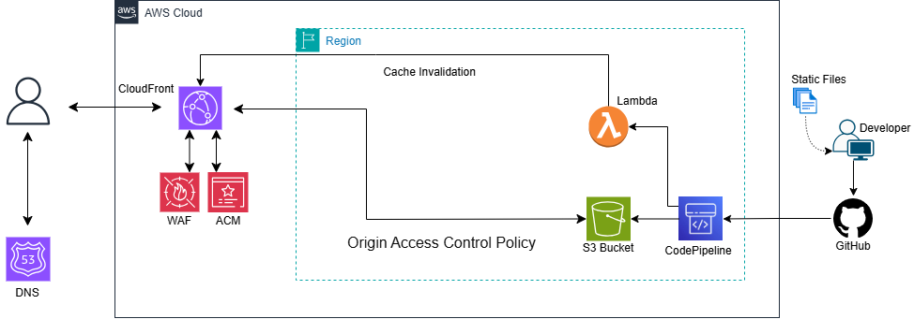

Workflow Diagram
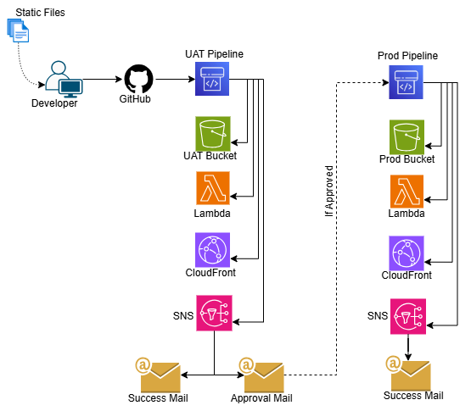

Service details

S3

As per Environment, 2 S3 Private Bucket has been Created.
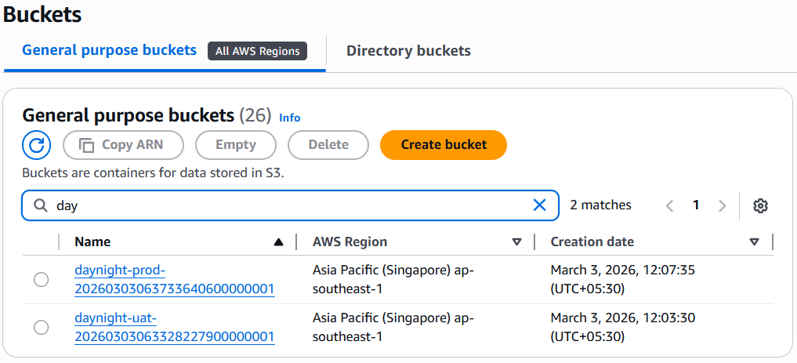

CloudFront

As per Environment, 2 CloudFront has been Created with OAC Access.

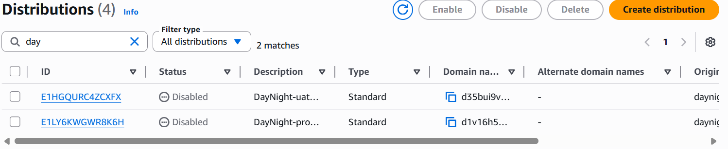

CodeStar Connection
CodeStart Connection is created with Application Tag and GitHub is connected.
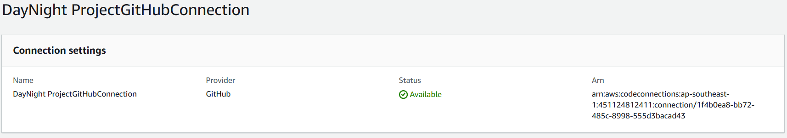

Lambda
As per Environment, 2 Lambda Function is created for cache Invalidation and 2 Lambda Function is for CodePipeline Test Stage

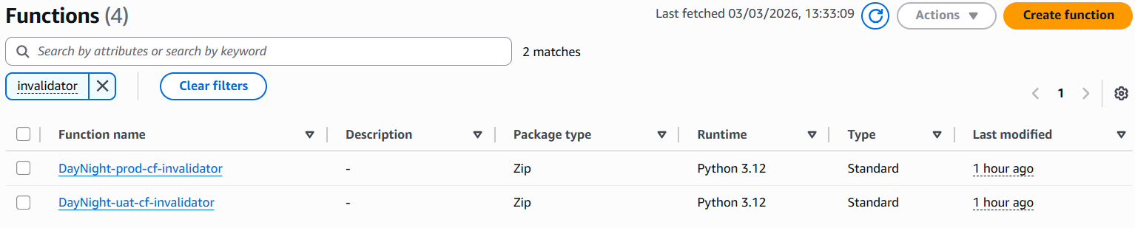

SNS
A single SNS is created for Mailing about the Pipeline Status.
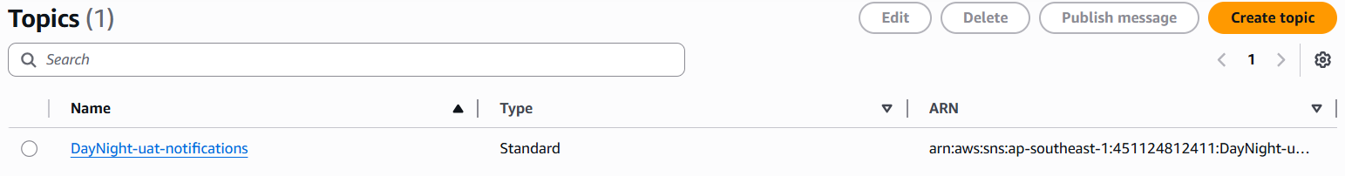
  - EventBridge

After CodePipeline is executed it will trigger EventBridge and then it will sent Email through SNS

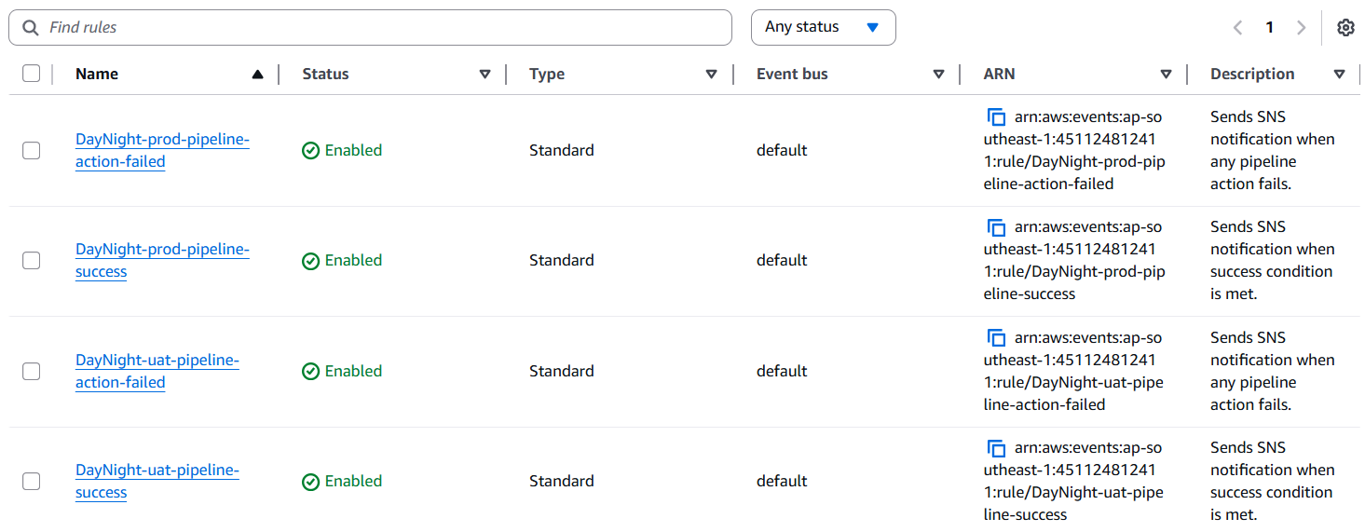

  - CodePipeline

As per Environment, 2 CodePipeline is Create and both have Overall Similar Stages

    - UAT Pipeline
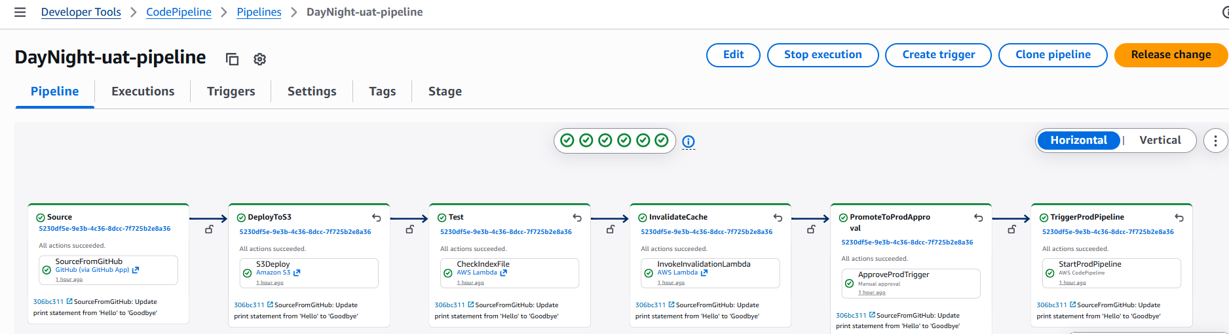

    - Prod Pipeline

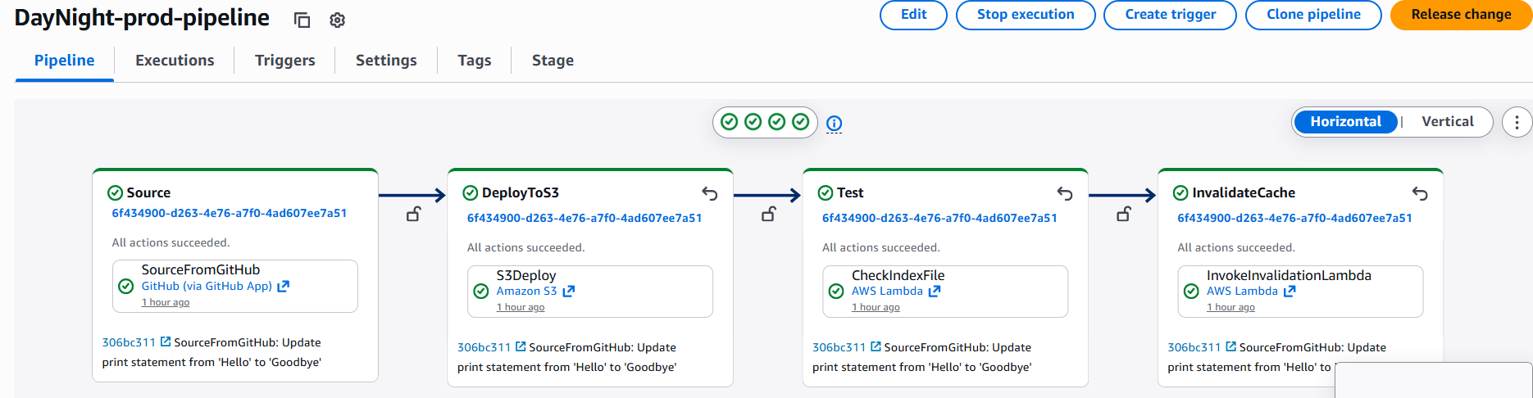

Security details
- S3 buckets block all public access.
- CloudFront Origin Access Control (OAC) restricts direct S3 access.
- HTTPS-only content delivery enforced.
- Separate IAM roles for UAT and Production.
- Lambda functions use least-privilege IAM policies.
- CodePipeline roles restricted to required permissions only.

Monitoring & Notifications
- SNS sends email notifications for pipeline success and failure.
- CloudWatch logs store Lambda execution logs.
- Pipeline execution history available in AWS Console.

Backup & Recovery
- S3 versioning enabled to retain previous object versions.
- Terraform Infrastructure as Code allows full environment recreation.
- Deployment failures prevent incorrect production releases.

Contacts of Customer, escalation matrix
Precision Escalation Matrix

Level | Name | Mail ID

Sign off Acceptance.
In witness whereof, the parties have executed this agreement on the date first written above.

For Precision Informatic (M) Pvt. Ltd., DayNight Software
Signature Signature
Name Name
Designation Designation

---------------------------------------------END OF DOCUMENT---------------------------------------------------

